מעבדה 4
מגישים:
טל יהושע, ת"ז 314774860
משה פרץ, ת"ז 318263977

תוכנית תרגיל מס' 1:

;Q1.ASM
.MODEL SMALL
.STACK 100H
.DATA
N DB 3
ARR1 DB 0,0,0
ARR2 DB 0,0,0
.CODE
MOV AX,@DATA
MOV DS,AX ; Set DS to point to data segment
MOV CL,N ; Set the loop action to repeat N times
XOR CH,CH ; Setting the ch to 0 so have the right N times
MOV AL,N
LEA SI,ARR1 ;keeping the relative address of the start of arr1
JCXZ ALOP ; jump ALOP if cx==0
LOP:
MOV [SI],AL ;Putting the numebrs in arr1 according to order
ADD AL,'0' ;for putting its ascii in arr2
MOV [SI+3],AL ; save it on arr2 string
SUB AL,'0'
DEC AL ;N=N-1, decreasing the N
INC SI ;moving the pointer one byte forward
LOOP LOP
ALOP:
MOV AH,4CH ; Set terminate option for int 21h
INT 21H ; Return to DOS (terminate program)
END

Dump:
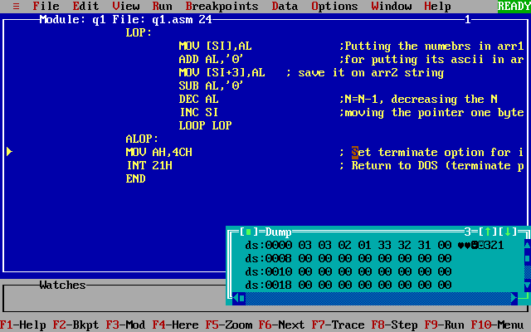

תוכנית תרגיל מס' 2:
;Q2.ASM
.MODEL SMALL
.STACK 100H
.DATA
NUM DQ 0
ARR DW 1,23,450,67
TEN DD 10
Print DB 13,10,'Last digit in the sum is: X',13,10,'$'
.386
.CODE
MOV AX,@DATA
MOV DS,AX ; Set DS to point to data segment
LEA SI,ARR ;keeping the relative address of the start of arr1
MOV CX,4 ; Set the loop action to repeat 4 times as the arr length
JCXZ Skip ;Jump to Skip if cx==0
body:
XOR EAX,EAX ;resseting the whole EAX
MOV AX,[SI] ;moving the array values to AX
MUL EAX ;Multiply EAX by itself to get the power of EAX
ADD DWORD PTR NUM,EAX ;adding the result to the right size variable(DQ size)
ADC DWORD PTR NUM +4,EDX ;adding the carry of the previous sum in the right place,4 bytes forward
ADD SI,2 ;adding 2 to si so si will move to bytes as the size of each variable in the array
LOOP body
Skip:
XOR EAX,EAX ;resseting the whole EAX and prep for Div
XOR EDX,EDX ;resseting the whole EAX and prep for Div
MOV EAX, DWORD PTR NUM ;moving the variable num to EDX:EAX respectively
MOV EDX,DWORD PTR NUM +4
;
DIV TEN ;Divide by ten and extract the units
ADD DL,'0' ;adding ascii'0' for printing
MOV Print[28],DL ;replacing the 'x' in the array with the units result
;screen output units result
MOV AH,9
MOV DX,OFFSET Print
INT 21H
;
MOV AH,4CH ; Set terminate option for int 21h
INT 21H ; Return to DOS (terminate program)
END

פלטים + רגיסטרים:
{ 1,23,450,67}
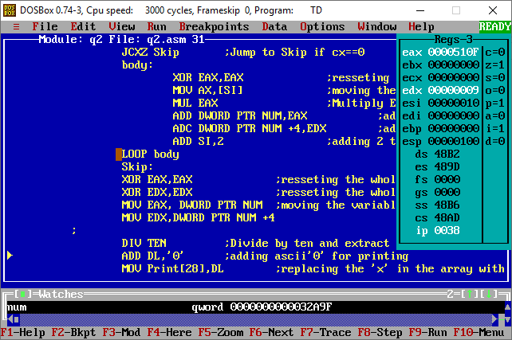

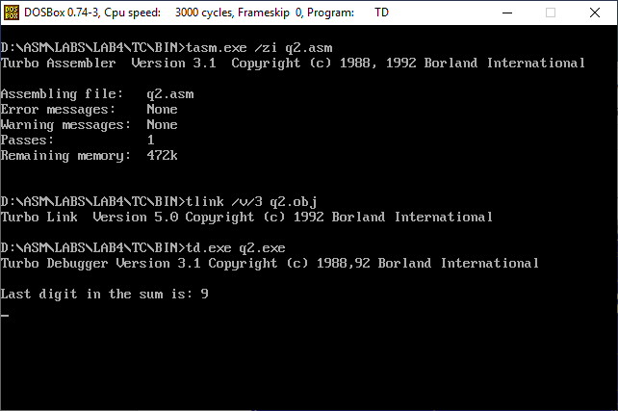

{1234, 9999,1111, 4444}
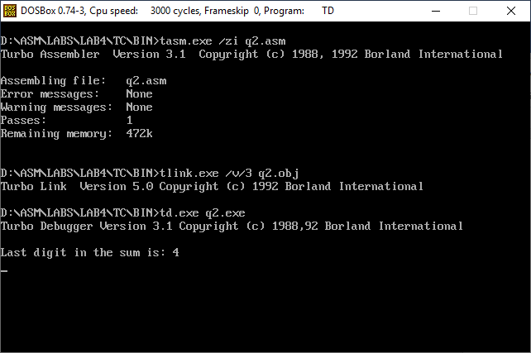
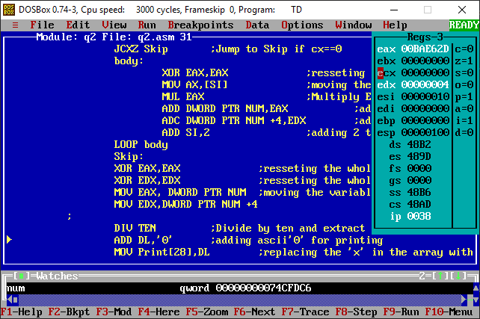

{60000, 1, 1, 1}
